Exam
Name___________________________________

TRUE/FALSE. Write 'T' if the statement is true and 'F' if the statement is false.

1)

Boolean multiplication is symbolized by A + B.
1)
_______

2)

In Boolean algebra, 1 ∙ 0 = 0.
2)
_______

3)

The complement of 1 is 0.
3)
_______

4)

The Boolean expression X = ABC describes a three-input AND gate.
4)
_______

5)

When a two-input NAND gate has inputs of 1 and 0, the output is 0.
5)
_______

6)

The commutative law of Boolean algebra states that A + B = A ∙ B.
6)
_______

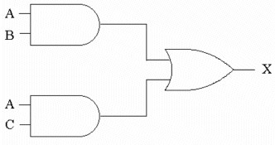
Figure 4-1

7)

According to the distributive law, Figure 4-1 shows one possible logic implementation of the expression X = A(B+C).
7)
_______

8)

For the circuit in Figure 4-1, X = 0 whenever A = 0, regardless of the levels applied to inputs B and C.
8)
_______

9)

DeMorgan's theorem states that XY = X + Y.
9)
_______

10)

DeMorgan's theorem states that = .
10)
______

11)

The Karnaugh maps provide graphic approaches to simplifying Boolean expressions.
11)
______

12)

The Sum-of-Product (SOP) form is a standard form of Boolean expression.
12)
______

13)

The Product-of-Sum (POS) form is a standard form of Boolean expression.
13)
______

14)

When mapping an SOP expression using a Karnaugh map a 0 is placed in each cell corresponding to the value of the product term.
14)
______

MULTIPLE CHOICE. Choose the one alternative that best completes the statement or answers the question.

15)

Which of the following is a correct form of Boolean addition?
15)
______

A)

0 + 1 = 0
B)
0 + 1 = 1
C)
0 ∙ 0 = 0
D)
0 ∙ 1 = 0

16)

Which of the following is a correct form of Boolean multiplication?
16)
______

A)

0 + 1 = 0
B)
0 ∙ 1 = 1
C)
0 ∙ 1 = 0
D)
0 + 1 = 1

17)

In Boolean algebra, the expression "________" means the complement of A.
17)
______

A)

not A
B)
inverse A
C)
negative A
D)
A negative

18)

The symbol shown below is a(n) ________, and the output will be ________ for the input shown.

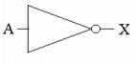
18)
______

A)

buffer, 1
B)
inverter, 1
C)
inverter, A
D)
buffer, not A

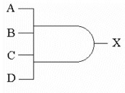
Figure 4-2

19)

The symbol shown in Figure 4-2 is a(n) ________ gate.
19)
______

A)

AND-OR
B)
AND
C)
OR
D)
NAND

20)

The Boolean expression for the symbol in Figure 4-2 is ________.
20)
______

A)

X = AB + BC
B)
X = A + B + C + D

C)

X = (A + B)(B + C)
D)
X = ABCD

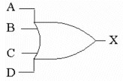
Figure 4-3

21)

The symbol shown in Figure 4-3 is a(n) ________ gate.
21)
______

A)

Exclusive-OR
B)
AND
C)
OR
D)
AND-OR

22)

The Boolean expression for the symbol in Figure 4-3 is ________.
22)
______

A)

X = (A + B)(B + C)
B)
X = ABCD

C)

X = AB + BC
D)
X = A + B + C + D

23)

The figure below represents one line from the truth table for a two-input NAND gate.

A B X
1 0 ?

For the inputs shown, what is the value of X?
23)
______

A)

1
B)
0
C)
B
D)
not A

24)

The expression for a 3-input NOR gate is ________.
24)
______

A)

X = A ∙ B ∙ C
B)
X = A + B + C
C)
X = A/B/C
D)
X = A + B + C

25)

Which of the examples below expresses the commutative law of multiplication?
25)
______

A)

AB = BA
B)
AB = A B
C)
AB = B + A
D)
A + B = B + A

26)

Which of the examples below expresses the associative law of addition?
26)
______

A)

A(BC) = (AB) + C
B)
A + (B + C) = (A + B) + C

C)

ABC = A + B + C
D)
A + (B + C) = A + (BC)

27)

Which of the examples below expresses the distributive law?
27)
______

A)

(A + B) + C = A + (B + C)
B)
A(BC) = (AB) + C

C)

A + (B + C) = AB + AC
D)
A(B + C) = AB + AC

28)

Which rule of Boolean algebra does the figure below illustrate?

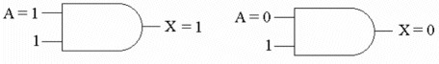
28)
______

A)

A + 1 = 1
B)
A ∙ 1 = A
C)
A + 0 = A
D)
A ∙ 0 = 0

29)

Which of the following is a form of DeMorgan's theorem?
29)
______

A)

X + 0 = 0
B)
XY = X + Y
C)
X(l) = X
D)
X + Y = X + Y

30)

Which of the figures is the DeMorgan equivalent of the Reference Circuit shown below?

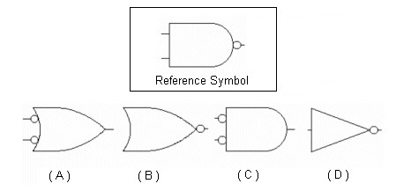
30)
______

A)

Figure (A)
B)
Figure (B)
C)
Figure (C)
D)
Figure (D)

31)

_______
According to DeMorgan's theorem, (AB) + C equals ________.
31)
______

A)

(A + B)C
B)
ABC
C)
+ C
D)
AB + C

32)

For the network shown below, the boolean expression for X is ________.

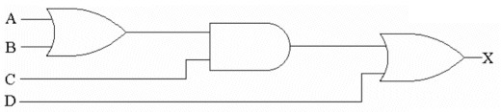
32)
______

A)

D(A + B + C)
B)
(AC + BC)D

C)

((A + B) ∙ C) + D
D)
A + BC + D

33)

Which of the following expressions is in the sum-of-products form?
33)
______

A)

(AB)(CD)
B)
AB + CD
C)
AB(CD)
D)
(A + B)(C + D)

34)

Which of the following is an important feature of the sum-of-products form of expressions?
34)
______

A)

All logic circuits are reduced to nothing more than simple AND and OR gates.

B)

The delay times are greatly reduced over other forms.

C)

The maximum number of gates that any signal must pass through is reduced by a factor of two.

D)

No signal must pass through more than 2 gates (not including inverters).

35)

Which of the following expressions is in the product-of sums form?
35)
______

A)

(AB)(CD)
B)
(A + B)(C + D)
C)
AB + CD
D)
AB(CD)

36)

What is the primary motivation for using Boolean algebra to simplify logic expressions?
36)
______

A)

It may reduce the number of inputs required.

B)

It may reduce the number of gates.

C)

It may make it easier to understand the circuit.

D)

All of the above are correct.

37)

Which statement below best describes a Karnaugh map?
37)
______

A)

Karnaugh maps provide a graphic approach to simplifying Boolean expressions.

B)

A Karnaugh map can be used to replace Boolean rules.

C)

Variable complements can be eliminated by using Karnaugh maps.

D)

The Karnaugh map eliminates the need for using NAND and NOR gates.

38)

Which of the Karnaugh maps below represents the expression, X = AC + BC + B?

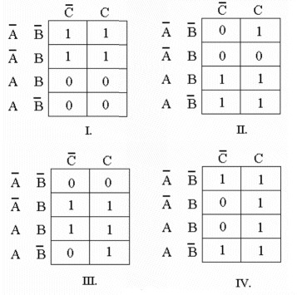
38)
______

A)

Figure I
B)
Figure II
C)
Figure III
D)
Figure IV

39)

The simplest Boolean expression for the Karnaugh map below is ________.

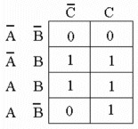
39)
______

A)

ABC + ABC + ABC
B)
X = AB

C)

X = AC + B
D)
AB + AB

40)

When grouping cells within a Karnaugh map, the cells must be combined in groups of ________.
40)
______

A)

3s
B)
2s
C)
2, 4, 8, etc.
D)
4s

41)

Occasionally, a particular logic expression will be of no consequence in the operation of a circuit, such as in a BCD-to-decimal converter. These result in ________ terms in the K-map and can be treated as either ________ or ________.
41)
______

A)

don't care, 1s, 0s,
B)
duplicate, 1s, 0s,

C)

spurious, 1s, 0s,
D)
spurious, ANDs, ORs,

42)

Which of the following combinations cannot be combined into Karnaugh-map groups?
42)
______

A)

Corners in the same column
B)
Diagonal corners

C)

Corners in the same row
D)
Overlapping combinations

43)

A Karnaugh map ________.
43)
______

A)

gives an overall picture of how the signals flow through the logic circuit

B)

provides a means of reducing complex Boolean expressions

C)

allows any circuit to be implemented with just AND and OR gates

D)

produces the simplest sum-of-products expression

SHORT ANSWER. Write the word or phrase that best completes each statement or answers the question.

44)

Reduce the following equation using Boolean Algebra.

A B C + A B C + A B C + A B C + A B C
44)
_____________

MULTIPLE CHOICE. Choose the one alternative that best completes the statement or answers the question.

45)

The Quine-McCluskey method of reducing complex Boolean expressions is used in place of a Karnaugh map when the original expression contains ________ or more variables.
45)
______

A)

6
B)
5
C)
8
D)
4

46)

The Quine-McCluskey method ________.
46)
______

A)

lends itself to computer reduction of Boolean expressions

B)

requires fewer steps than Karnaugh mapping

C)

can, under certain circumstances, provide incorrect results

D)

is described by all of the above

1)

FALSE

2)

TRUE

3)

TRUE

4)

TRUE

5)

FALSE

6)

FALSE

7)

TRUE

8)

TRUE

9)

FALSE

10)

TRUE

11)

TRUE

12)

TRUE

13)

TRUE

14)

FALSE

15)

B

16)

C

17)

A

18)

C

19)

B

20)

D

21)

C

22)

D

23)

A

24)

B

25)

A

26)

B

27)

D

28)

B

29)

B

30)

A

31)

B

32)

C

33)

B

34)

D

35)

B

36)

D

37)

A

38)

C

39)

C

40)

C

41)

A

42)

B

43)

B

44)

A B C + A B C + B C (A + A) + A B C

A B C + B C + B C (A + A)

C (A B + B) + B C

C (A + B) + B C

A C + B C + B C

45)

A

46)

A

